Scientific Knowledge
Day 2: Lesson Quiz
Choose the letter of the best answer.

1. Which statement describes how a scientist makes scientific explanations?
A. A scientist bases scientific explanations on a large body of observations of the world.
B. A scientist bases scientific explanations only on other scientists’ opinions.
C. A scientist bases scientific explanations on personal experience and opinions.
D. A scientist suggests scientific explanations and makes up evidence to make them true.
2. The figure below shows a concept related to the kinetic theory of matter, which describes the behavior of gases based on the motion of the particles.
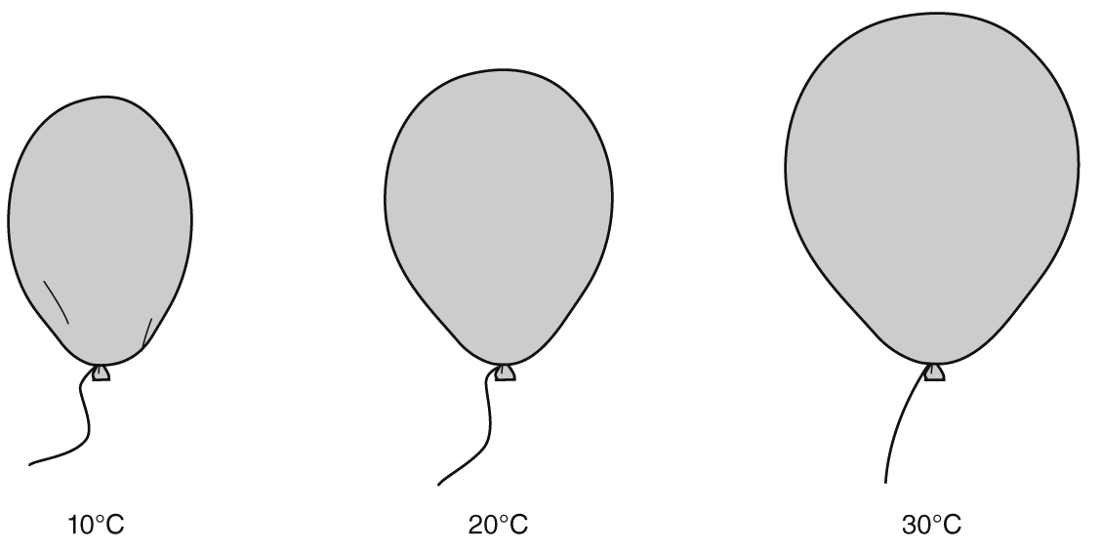
How would the kinetic theory explain what is happening in the above example?
A. The balloon gets bigger as the temperature of the gas inside it decreases, because the gas particles move faster and get farther apart.
B. The balloon gets smaller as the temperature of the gas inside it decreases, because the gas particles begin to escape from the balloon.
C. The balloon gets bigger as the temperature of the gas inside it increases, because the gas particles move faster and get farther apart.
D. The balloon gets smaller as the temperature of the gas inside it increases, because the gas particles move more slowly and get closer together.
3. Which of these scientists would most likely engage in fieldwork to observe organisms?
A. chemist
B. biologist
C. physicist
D. mathematician
4. Which of these events might lead to the modification of a scientific idea?
A. A scientist uses a computer to teach a scientific concept to students.
B. Two scientists doing the same experiment in different parts of the world under the same conditions get the same results.
C. One scientist finds evidence that she feels doesn’t fit a theory. Other scientists agree that her results are valid.
D. A scientist performs an experiment and finds out that one of the chemicals used in the experiment was contaminated.
5. Simon is presenting a project on scientific laws and theories. Which of the following statements should he include to explain the differences between the two?
A. Scientific theories requires scientific evidence but scientific laws do not.
B. Scientific theories are based on observations and scientific laws are based on opinions.
C. Scientific theories explain why something happens, and scientific laws describe what happens.
D. Scientific theories are rarely changed and scientific laws are modified frequently.

